ECO Comparison Tool Help Guide For Word© 2007

How to compare documents using the legal blackline option

The legal blackline option compares two documents (e.g., The exemplar and your expanded course outline) and highlights the differences between them. The documents that are being compared are not changed. The legal blackline comparison is displayed by default in a new third document which uses strikethrough and underline font to reveal differences. (Material extracted from Microsoft Word© Help button content.)
- Open both your Expanded Course Outline (ECO) and the appropriate Exemplar.
- To assist with consistency between this tutorial and your results, on the Review tab of either document, select “Track Changes,” open the “Change Tracking Options” dialogue, and adjust the markups as shown in #3 below.
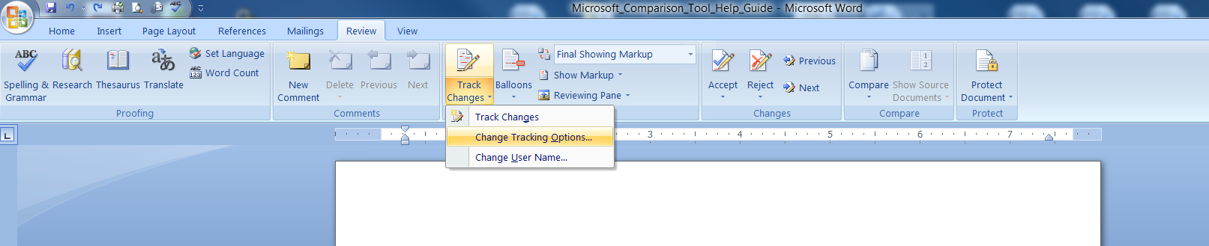
- Below are the Track Changes options used in this comparison tutorial. It is recommended you use the same settings.
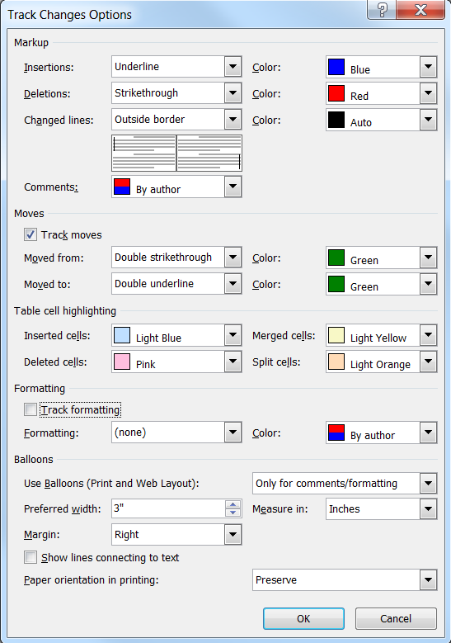
- While still on the Review tab, select Compare and click Compare-Compare two versions of a document (legal blackline).
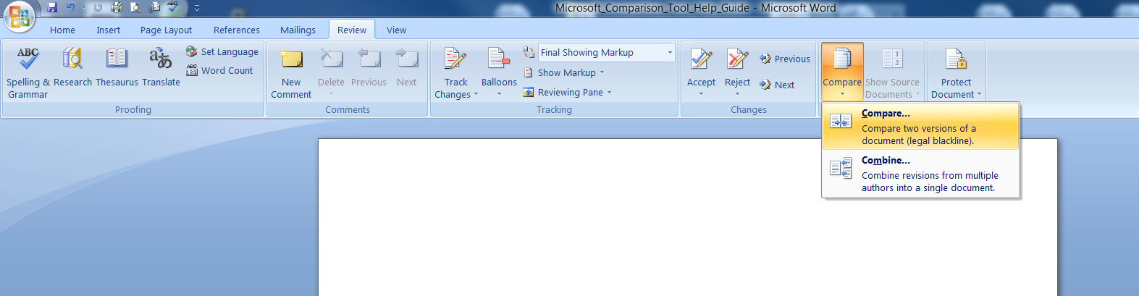
- A new dialogue box will open. This is where you select the documents to be compared.
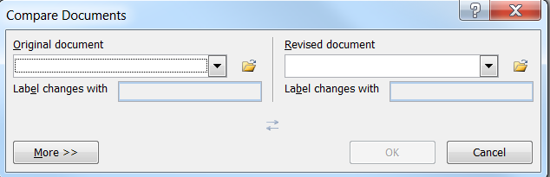
The Original document for our purposes is the Exemplar. The Original document is the document against which the Revised document (e.g., your ECO) is compared. You may adjust additional settings under “More>>” if desired. (Note: Any changes made will become the default settings the next time you compare documents.)
- In Original document, browse for and select the Exemplar you opened in #1. Its title should appear in the dropdown. Or, you may browse for the file through the file icon.
- In Revised document, browse for and select the ECO you opened in #1. Its title should appear in the dropdown. Or, you may browse for the file through the file icon.
The next step will reveal a document which results from the comparison of the Exemplar and your ECO. Depending on your settings, you may also see your original ECO and/or the Exemplar in additional windows.
- Click “OK”.
- If either version of the document has tracked changes, Microsoft Office Word© displays a message box. Click “Yes” to accept the changes and compare the documents.

- If multiple documents are visible, you can close the Original and Revised document windows to remove unnecessary visual distractions and make the resulting comparison document easier to view (see example below).
- If not already done, open your ECO and save it under a new title. This will become your updated ECO and you do not want to confuse it with the prior version(s). Minimize it so you can access it easily to make changes when you find them through the comparison result.
- In the comparison result, focus first on any strikethrough text since this may indicate that the minimum content required in the Training and Testing Specifications (TTS) is not in your ECO.
Compare the text in these areas of your ECO with the current TTS to determine if your ECO incorrectly omits the required text. If it does, then you need to add the text to your ECO.
- It is possible text shown as deleted or missing (e.g., strikethrough) might be present but the tool did not find it. This often occurs due to formatting and you should determine if the strikethrough text is actually located nearby before adding it to your ECO.

- Differences in headers, titles, and format are permissible. Focus on content.
- The underlined text indicates your added content. Additional content is required (to the “third level”) and is expected in order for you to properly cover the topics. Additionally, double-strikethrough and double-underline text indicates text has been moved. Like the false deletions noted in #12 above, this is often only a formatting issue but you should still review your ECO to make sure the required content is present.
- It is highly recommended you adjust placement of content shown by the comparison as moved or erroneously as deleted. This greatly aids in future reviews and comparisons by allowing focus on content and actual, rather than false, errors.

- If you have a significant number of false deletions or other problems due to formatting, it is a good investment of time to use the Exemplar as the base for a new ECO and then move (cut/paste) your additional items into that document. This process eliminates many formatting ‘errors’ that are revealed during comparisons.
- Once you have updated your ECO with any missing content, your revised ECO should now contain the minimum required content, along with your presenter-specific information, and be ready for submission. To verify, you should compare your new outline with the exemplar again to ensure the previous omissions were corrected.
- Ensure affected instructors are aware of the ECO content changes.
EXAMPLES
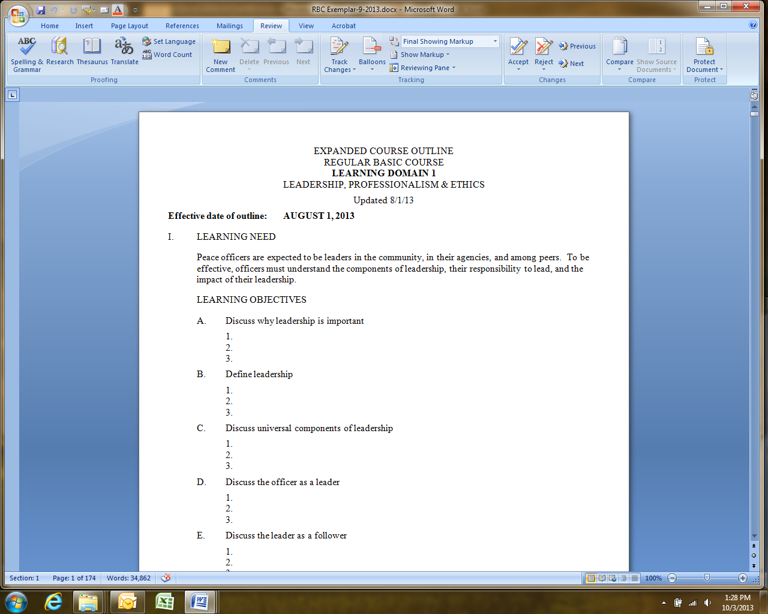
An Exemplar for the RBC (#1 above).
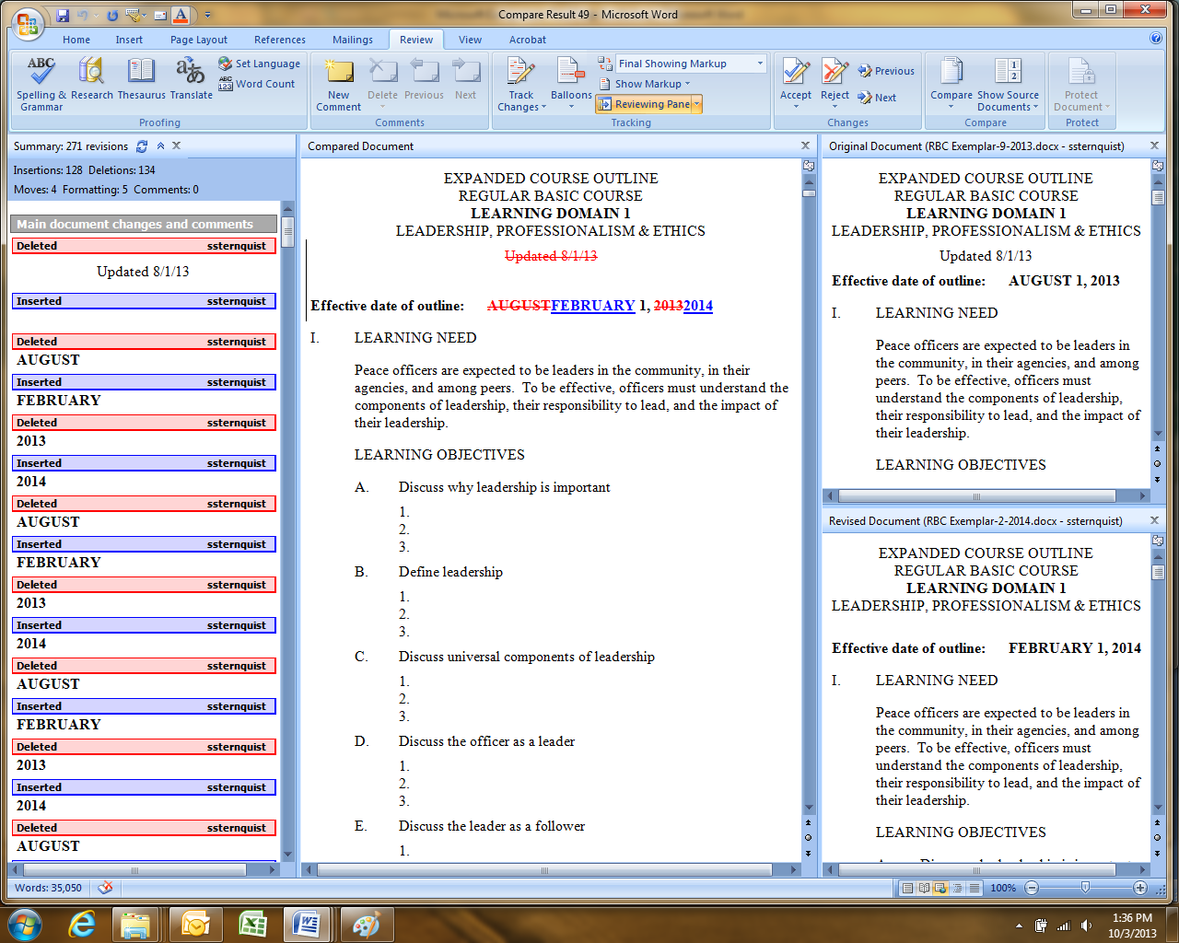
You may want to close the additional windows indicated to more easily focus on the comparison document.
The comparison result with optional windows showing (#10 above).

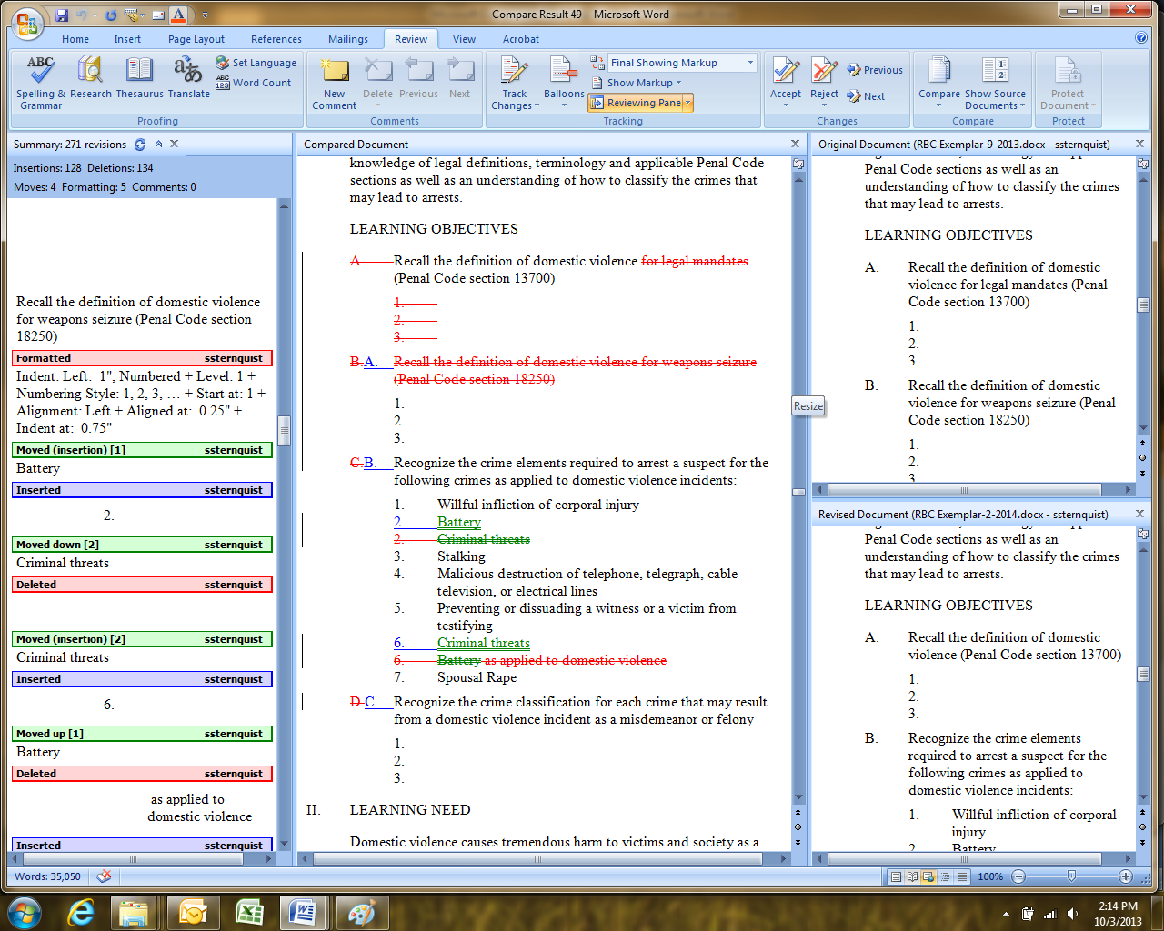
Moved content
Missing content

Example showing typical markups (#12 & 13 above).

Presenters with questions related to the Exemplar or the Basic Course may contact Basic Training Bureau staff at 916-227-4252.

