ECO Comparison Tool Help Guide for Word® 2013

Comparing Documents

Below are general instructions for using the comparison tool to ensure your expanded course outline contains the required Training and Testing Specifications’ (TTS) content by utilizing the basic course exemplars.

The comparison feature in MS Word® 2013 compares two documents and highlights the differences between them (e.g., comparing the exemplar with your expanded course outline reveals the differences in content between the two). This allows reviewers to determine if the minimum or required content is present in outlines being submitted for further review and approval.

The documents that are being compared are not changed. Instead, a new document using strikethrough and underline text to reveal the differences is displayed by default.

Getting Started

- Before initiating the comparison, it is recommended users adjust the Track Changes Options in Word® as directed below to provide consistency with these instructions.

To change the color and formatting of the comparison results, go to the Review tab and click the dialog launcher (the little arrow in the bottom right corner of the Track Changes selection area). Then, in the Track Changes Options dialog, click Advanced Options

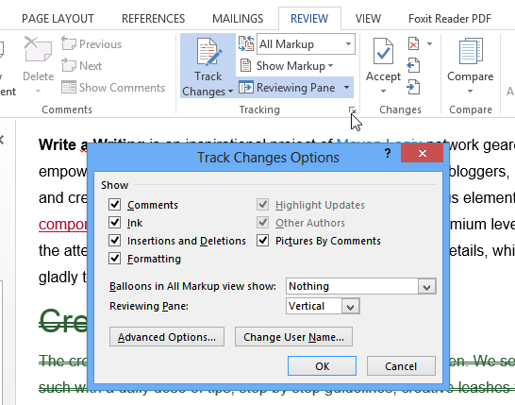
1

- In the newly opened Track Changes Options dialog (below), you can specify the color and formatting of insertions and deletions, changed lines, and comments. The settings below align with those POST uses both in these instructions and during staff comparisons.
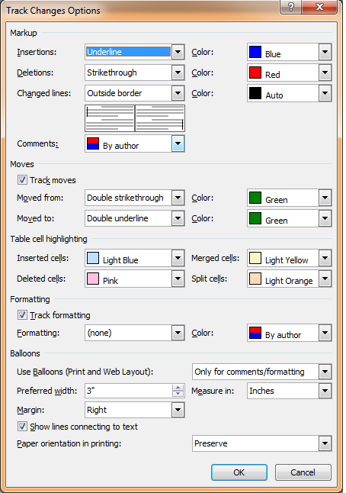

Once your settings, especially those for insertions, deletions, and moves, match those above, click “OK” and then follow the instruction in #3 below.

- Open both your Expanded Course Outline and the appropriate Exemplar for your course (found on the Basic Course Informational Website under “Expanded Course Outline”).

In the review tab of either document, find the Compare group and click Compare.

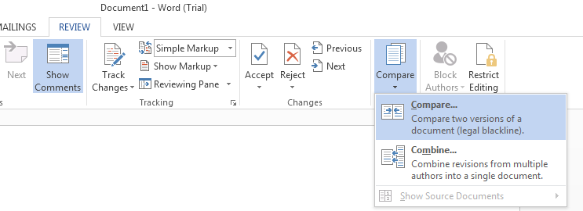
- A new Compare Documents dialog will open.

Under “Original document” browse for and select the Exemplar. This is the source document which the other (revised) document will be compared against. The document title will be in the drop-down box if the document is open.
Likewise, under “Revised document” browse for and select your Expanded Course Outline (ECO).
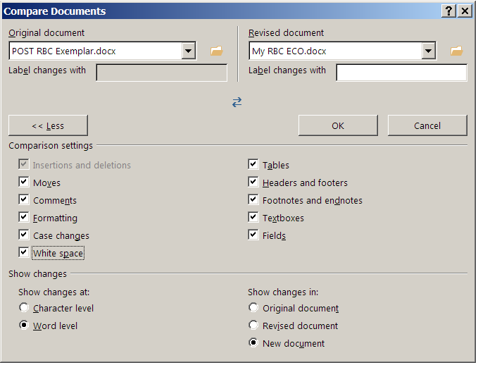
Original document: POST’s Exemplar for your course

Revised document: Your ECO

- Under “More”, you can adjust the settings (expanded in the picture below “<<Less” above) for what you want to compare in the documents, if necessary. Note: Any options that you select under More will be the default options for comparison the next time you compare documents.
Once you select the proper Original and Revised documents, click OK.

Note: If either of the documents included tracked changes, Word® will display a message box.

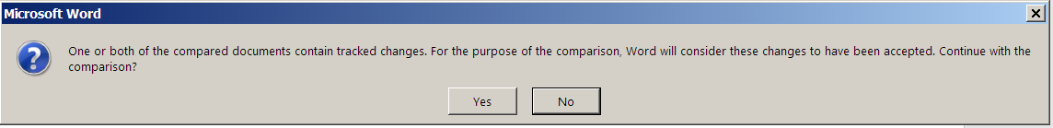

Click ‘Yes’ to accept the changes and move forward with comparing the documents.

- Word® will then compare the documents and provide you with at least one, but possibly three or more different windows (depending on your settings). The typical windows include: the new “Compared Document” in which changes from the original document are noted, the “Original” document, and the “Revised” document (see Example #1). Closing the original and revised windows may enhance your ability to conduct the review.

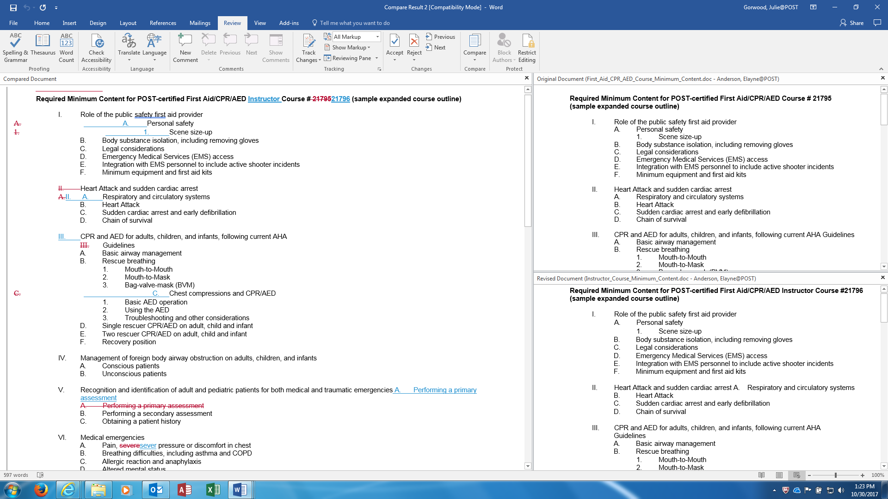
Your ECO
Comparison Results
Option: Close these two windows

Exemplar
Example #1

Example #1’s Compared Document reveals differences between your ECO and the Exemplar by using strikethrough for missing/deleted content and underscore for added content. The Original is simply a copy of the Exemplar and the Revised a copy of your ECO. Some prefer to close the Original and Revised document windows to make reviewing the Compared document’s results easier.

Note: If the comparison result appears as in Example 1A below, click on the red lines to the left to enable a view of the changes as shown in Example #1.
Example #1A
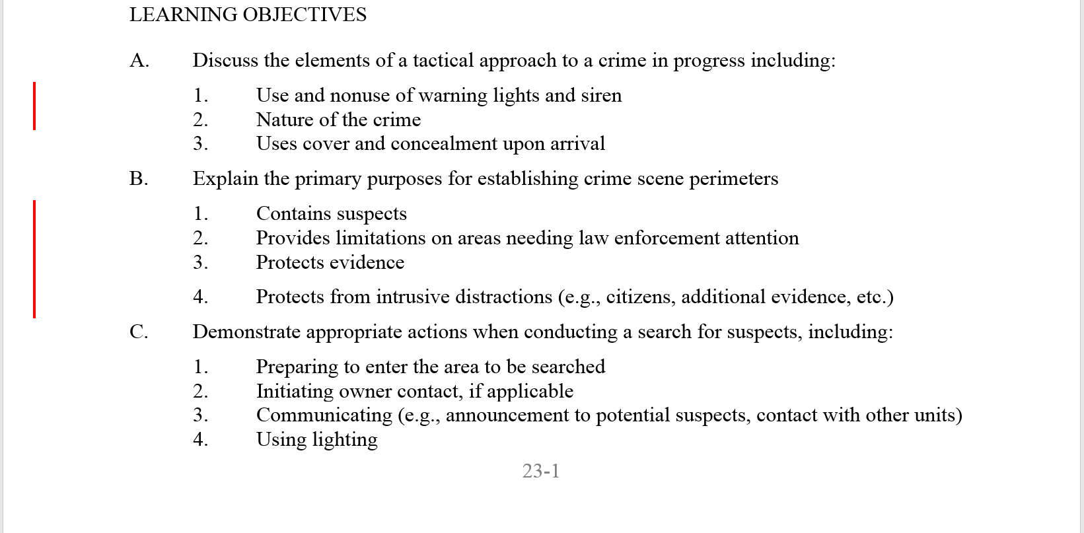
Click to expand

- Begin reviewing the Compared Document. All black text with no additional markings shows matching (required) text. Strikethrough text likely indicates your ECO is missing required content. The underscored text identifies content your ECO has in addition to the TTS (which is expected and required to the third level). Text moved in the document appears as green double underscore/strikethrough font. See Example #2 below to further explain markings you may see.

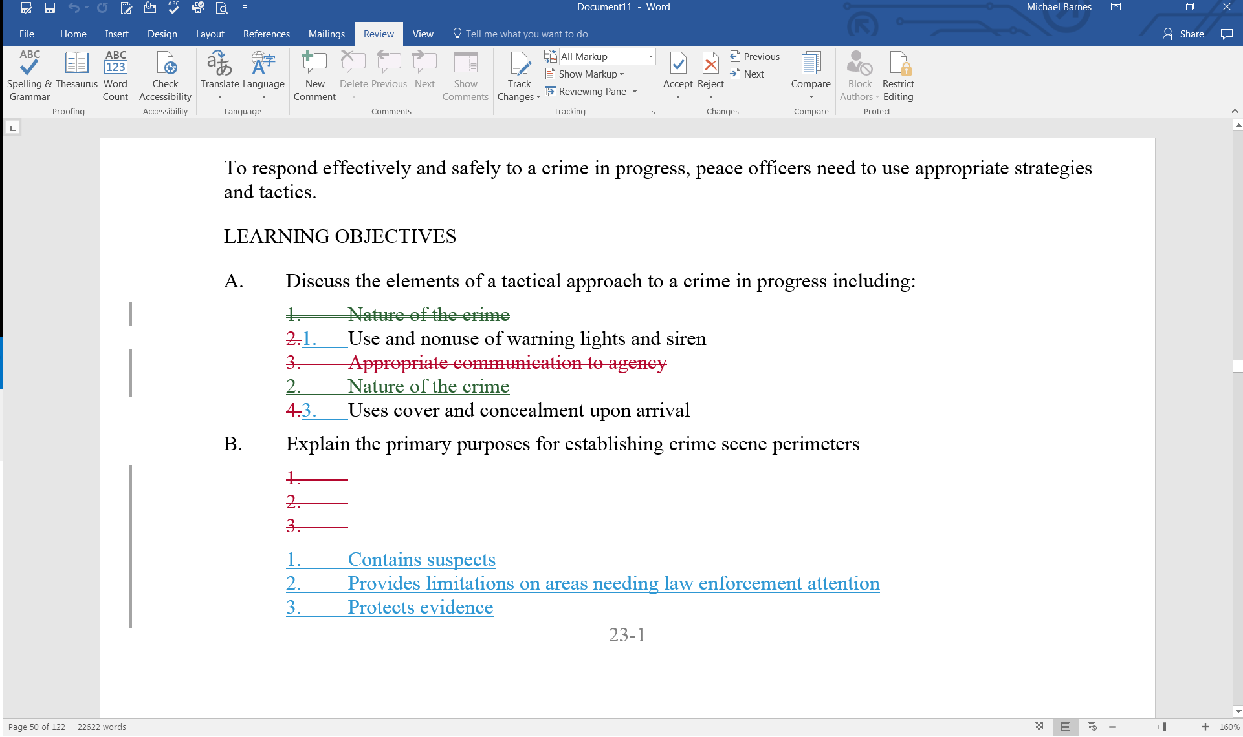
Green: Content that has been moved
Blue: New content
Black: POST matching content
Red Strikethrough: Deleted content; likely missing required content
Example #2

As you identify missing or incorrect content, correct your separately opened ECO so it includes all required content as specified in the exemplar/TTS. Differences to headers, titles and format are expected (e.g., the deletion of the outline numerals 1-3 above)--Focus on content.

- If you have any doubt that the content identified in the comparison is actually needing inclusion/correction in your ECO, review the appropriate sections of the TTS to verify the current content requirements. The TTS content must be in your ECO exactly as written.

It is possible the tool may erroneously identify existing text as missing (strikethrough) simply because it is moved (often nearby). You should verify potentially missing text is not located elsewhere before adding it to your new ECO. See Example #3 below for a sample of this erroneous result.

Example #3

Example #3 shows how the comparison result may indicate a problem with the ECO when none exists. Read the comments in blue text for a description of the false errors.

- Upon editing your ECO as noted above, it should now contain the minimum required content along with your presenter-specific information and be ready for submission.

To verify, you should conduct the comparison of your new outline to the exemplar again to verify all errors have been corrected. Correct any remaining errors, and after saving the new outline conduct another comparison before submitting for POST review.
Note: When you accept changes, you may get a box that gives you a selection to choose from. Choose “accept all and stop tracking”.

- Ensure affected instructors are aware of ECO content changes so the actual course presentation matches your POST-certified content.

